Name: ___________________________________ Date: ________________ Per: ______
Vocab - Ecological Succession Due: ____________________________
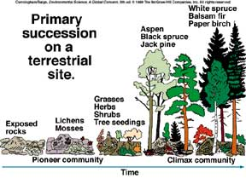

Word | Definition | Sentence
1. Autotrophs

2. Heterotrophs

3. Terrestrial
Ecosystem

4. Symbiosis

5. Lichens

6. Algae

7. Fungi

8. Organic

9. Inorganic

10. Ecological
Succession

11. Ecotone

12. Mutualism

